Premier League Financial & Performance Dissertation Project

By Arron Singh

September 2025

Table of Contents
Abstract: 3
Introduction: 3
Literature Review: 4
Methodology: 6
Results & Analysis: 11
Evaluation: 18
Conclusion: 23
References: 25

Abstract:
The financial and competitive dynamics of the Premier League continue to attract global attention, with clubs investing heavily in wages, transfers and infrastructure in order to achieve sporting success; however, financial strength does not always guarantee performances on the pitch. While individual financial and performance data are widely available, they rarely integrate into a single interactive platform that allows comparisons of clubs across a season. This project addresses the gap by designing and developing a Tableau dashboard that unifies financial and performance data for Premier Clubs, offering a deeper insight into efficiency, spending effectiveness and the relationship between finance and performance. The study aimed to investigate how financial and performance data can be combined to evaluate club efficiency. The objectives of the project that guided the project were to collect, clean and validate financial and performance data for Premier League clubs across three seasons. To define and implement key performance indicators (KPIs) such as Cost per Point, Wins per Wage and Revenue by League Position. Next was to design and construct an interactive dashboard using Tableau, and lastly was to analyse the resulting visualisations to identify patterns, correlations and anomalies in the data. The data was compiled from publicly available sources, such as Transfermarkt and official club reports, alongside performance statistics such as league points, wins and goals. After clearing and standardising the data, KPI were created to allow consistent comparison. Tableau was used to visualise the dataset, chosen for its ability to provide interactivity, filtering and clean KPI displays. The results confirmed that higher spending on wages and transfers typically correlates with league success, as seen with Manchester City and Liverpool. However, efficient outliers such as Brighton and Brentford consistently showed strong returns relative to their budgets, while clubs such as Chelsea and Manchester United demonstrated poor cost effectiveness, despite their financial power. The Project contributes academically by extending the study of football finance with a visual framework that highlights performance alongside financial power. Practically, the dashboard demonstrates how interactive visual tools can support decision making for club executives, analysts and a variety of other users. Limitations such as inconsistent financial disclosures, the absence of player-level data, and a restricted timeframe suggest avenues for future development, including expanding to other leagues, adding commercial metrics and incorporating predictive models. In conclusion, the project shows that integrating financial and performance data in an interactive dashboard offers valuable insights into efficiency in professional football.
Introduction:
The Premier League is widely regarded as the most competitive and is the highest revenue-generating league in the world (Plumley, Ramchandani and Wilson, 2018) due to the financial power it has through TV deals, but also the competitiveness of the league between the clubs (Gaul, 2024). However, financial strength does not always translate into on-pitch success. Clubs invest heavily in transfers and wages, yet their performance often varies widely. Understanding the relationship between a club’s financial decision and its sporting outcome has become increasingly important not only for clubs themselves but also for analysts, investors and fans. While financial reports and performance statistics are commonly available, they are rarely brought together in a clear interactive format that enables dynamic comparison across seasons and clubs. There is a lack of accessible visual tools that help decision-makers evaluate how clubs are spending and how that spending correlates with success. The aim of this project is to design and develop an interactive dashboard that compares Premier League clubs’ financial performance metrics, like revenue, wages, and net spend, with their sporting performance metrics, like league position, points, and wins. The dashboard seeks to provide insights into spending efficiency, cost effectiveness and the financial strategies of different clubs.

Objectives:
To achieve this aim, the following objectives were set:

- To gather and clean financial and performance data for all Premier League clubs from the 2020/21 to 2023/24 seasons.
- To define and calculate key performance indicators (KPIs) such as net spend, income. Cost per point and revenue per fan.
- To design and build a professional Tableau dashboard
- To analyse the data through interactive visualisations that highlight trends, correlation, and anomalies.

Structure of the Report:
The documentation of this project is documented in the following sections of this report:

- Literature Review: Reviews existing literature on football finance, performance analysis and data visualisations in sports.
- Methodology: Outlines the methodology used, including data sources, processing steps and dashboard development.
- Results & Analysis: Presents the key insights and visual analysis from the dashboard
- Evaluation: Assess the project against its objectives and the evaluation of the project.
- Conclusion: Summarise the achievements of the project and explore potential future developments and improvements.

Literature Review:
In recent years, the role of data analytics and visualisation has become increasingly prominent in the sports industry. From improving on-field performance to managing financial performance and strategy, which allows clubs to leverage data-driven insights to make more informed decisions. As the amount and complexity of data grow, there is a need for accessible interactive tools that allow stakeholders to extract value from both financial and performance-related metrics. (Anon, 2021)

The purpose of this literature review is to explore the current landscape of sports data visualisation and identify how existing tools and techniques have been applied in these related domains. Specifically, it aims to examine the methods used to visualise player and team performance, financial indicators, and how these have been integrated into interactive dashboards. By reviewing relevant research and visualisation frameworks, this will identify gaps in current approaches and highlight how the present project contributes to bridging these gaps. This review will be structured around key themes such as Sports data analytics and performance visualisation, visualisation techniques in sports, financial data representation and user interaction in dashboards.
Sports Data Analytics and Performance Visualisation:
The integration of data analytics in sports has revolutionised how teams and stakeholders make decisions, from making intuition-based judgements to data-driven strategies. Performance metrics such as goals, assists, distance covered, and xG(expected goals) are increasingly monitored to evaluate player and team effectiveness. (Butt, 2024) The use of sport-specific performance analytics has increased significantly due to advances in tracking technologies and the availability of open-source sports data. The study mentions how visual analytics platforms support coaching decisions by identifying performance patterns that may not be immediately obvious through raw data. These platforms leverage tools like heatmaps, time-series charts and passing network diagrams to provide context in understanding game events. (Dickson,2020)
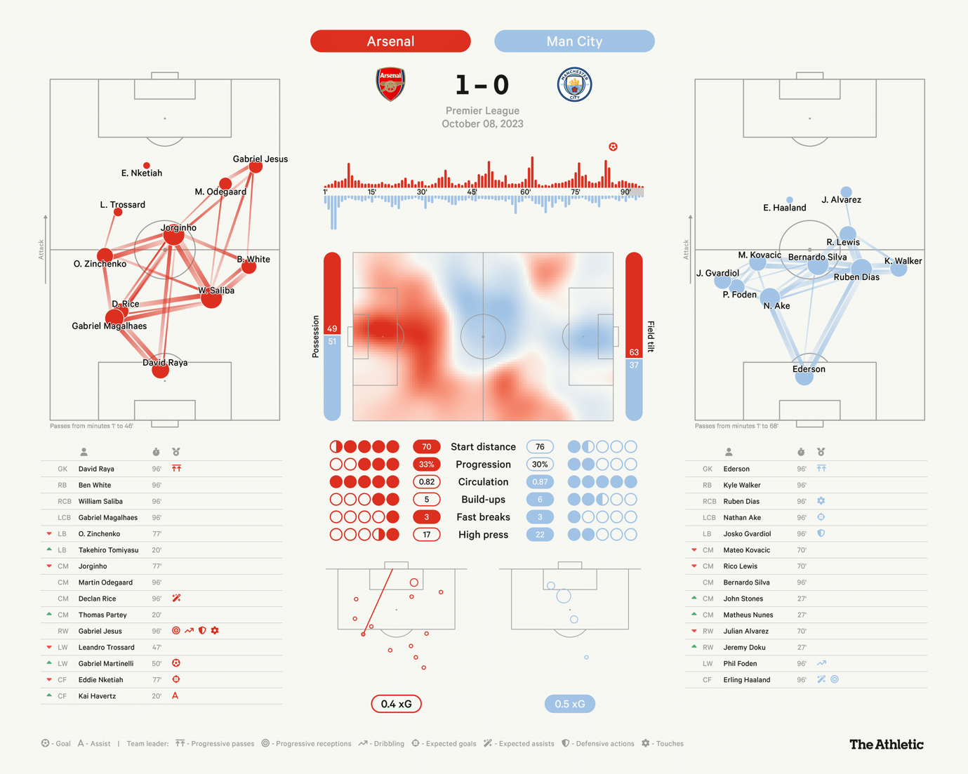
Figure 1: Match Dashboard( Muller, 2023)

Predictive analytics can enhance performance forecasting in football by showing how data can be used to predict future outcomes, such as league positions and match results. This approach emphasises the value of longitudinal data for drawing insights, a concept that can be used for using data from previous seasons to then predict future results. (Fan et al., 2023)

Despite the growing use of analytics in evaluation in physical and technical performance, there remains a gap in tools that integrate financial data, such as player wages or transfer spending, with performance outputs like points, league positions or goal difference. The ability to visualise both operation and financial performance simultaneously could enhance strategic planning, particularly in areas like squad investment, return on spending or cost efficiency. (ResearchGate, n.d.) Visual analytics tools are most effective when they go beyond display and support decision-making. The ability to dynamically filter, compare and drill down into specific metrics across multiple seasons adds significant value to performance and initial planning. (Kazmi, O’Grady and Gregory, 2011)

Financial Decision-Making in Professional Sports Clubs:
Financial management plays a critical role in the sustainability and competitiveness of professional sports clubs. Revenue sources such as broadcasting rights, matchday income, sponsorships, and merchandising must be balanced against growing expenditures on player wages, transfer fees and infrastructure. With football clubs often operating on thin profit margins, decision-makers require tools that can evaluate both financial input and sporting output simultaneously. (Dickson,2020) While financial reports and accounting systems are common, they often operate independently from performance analytics. As a result, many clubs struggle to assess the efficiency of their spending from a football point of view, such as how investment in player wages will correlate to their league position. (Fan et al., 2023)
One major challenge is that not all financial inputs lead to proportional sporting success. Clubs with smaller budgets may outperform richer teams due to better recruitment, tactical insight, or coaching. Therefore, simply increasing financial input does not guarantee improved output; this makes efficiency-based metrics such as net spend per point or wage efficiency crucial to assessing club performance in a financially meaningful way. (Kazmi, O’Grady and Gregory, 2011). There is growing recognition of the value of benchmarking clubs not only by trophies won or goals but also by financial effectiveness. Dashboards that support this kind of evaluation can allow clubs to model how their performance compares to rivals with similar or different constraints (Fan et al., 2023). Integrating financial and performance data into a single interface platform offers greater transparency and insight for stakeholders, including owners, analysts and management.

The review of existing literature highlights the increasing importance of data-driven approaches within football, specifically in areas of performance analytics, player tracking and injury prevention. Modern technologies and analytical frameworks have provided coaches and analysts with robust tools to monitor player workload, tactical patterns and matchday performance. (Kazmi, O’Grady and Gregory, 2011) Several studies have underscored the need for better alignment between financial data and performance outcomes. Research acknowledges the complex relationship between investments such as wages or transfer spending and results like league position or points. (Dickson,2020) Despite the presence of dashboards and business intelligence tools in commercial sectors, their application in football remains minimal. While some studies propose frameworks for integrating performance and financial KPIs, few deliver practical applications for non-technical stakeholders such as executives or board members. (ResearchGate, n.d.) Additionally, the majority of dashboards prioritise team performance rather than evaluating club-level efficiency across seasons and against financial metrics. The key gap within this area of study is the lack of a unified, interactive dashboard that connects financial metrics like revenue, wage costs, transfer spend, etc, with performance data like points, goals, league positions over multiple seasons. The absence of such tools makes it difficult to evaluate operational efficiency or support evidence-based strategic decisions. This project directly addresses that gap by designing a dashboard that blends both financial and performance indicators for Premier League clubs across multiple seasons, and in doing so, the project bridges the divide between finance and performance, offering a visual and analytical tool tailored for decision-makers in football.

Methodology:
This chapter will outline the methodology adopted for developing the dashboard. The aim of the project was to integrate club-level financial and performance data into a single interactive visualisation tool to support analytical insights. The methodology section will explain how the data was collected, cleaned and analysed, as well as how key performance indicators (KPIs) were defined and visualised using Tableau. Each stage in the development process was specifically planned to ensure the project aligned with the research question “How can financial and performance data be integrated to support business decision-making in professional sports clubs?” and the requirements of a data-driven style dashboard.

Tools Selection and Justification:
The three main tools that were used for this project were Excel, SQL and Tableau. Each tool served a specific purpose for each phase of the project and was selected based on its capability in handling different parts of the data preparation and visualisation process. Microsoft Excel was used in the early stages for the creation and structuring of the dataset. Due to how the data was presented from the sources, much of the information had to be manually organised into the spreadsheet from various data sources. It was also used for creating calculated columns such as Net Spend, Revenue Per point and more and helped in organising and manipulating data to be ready for analysis (Khan, 2023). Once the dataset reached near completion, it was imported into MySQL to perform formal data validation, cleaning and consistency checks. SQL was chosen over Excel for this stage due to its scalability and reliability when dealing with larger datasets, and also to validate data without manual effort to reduce human error (PREDNY SLM, 2023). Tableau was the main tool used for data visualisation and dashboard creation due to its strong visual capabilities and the ability to handle large datasets. (Datadrive, 2023)
Research Design:
Initially, the project focused on data from the 2023/24 Premier League season. However, during the data analysis phase, it became evident that using a single season limited the ability to draw broader insights or track trends, as you can see in the first completed version of the dataset. As a result, the scope of the dataset was expanded to include three full seasons: 2021/22, 2022/23, and 2023/24 to adopt a longitudinal design, allowing for the tracking of trends in financial efficiency and performance over time rather than in a single season, and further validates the data. (Simkus, 2023)
Data Collection:
Data was collected from a variety of publicly available sources that provide reliable financial and performance statistics for the Premier League. Financial data, including revenue, wages, transfer expenditure, and transfer income, was sourced from platforms such as Transfermarkt, which is a comprehensive database and portal for football data that includes a variety of different information from performance to finance and other online football databases (Transfermarkt, 2025). Performance data such as points, goals scored, league positions, and results (wins, draws, losses) were obtained from official football statistics websites and trusted sports platforms.
Evolution of the Dataset:
An Excel spreadsheet was used to compile and organise the data. Each row in the spreadsheet represented a club season combination, and each column held either data from the data sources or a calculated metric. Initially, the dataset was constructed using only 2023/24 season data. However, after conducting early analysis and dashboard mock-ups, it became clear that incorporating additional seasons would improve trend identification and provide greater insight for the analysis.
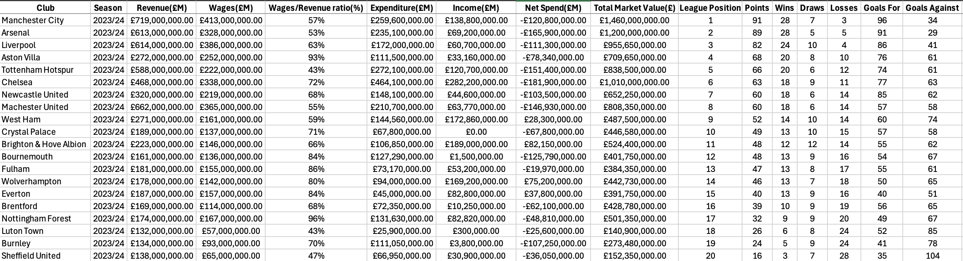
Figure 2: First Completed Version of Dataset
The dataset evolved significantly throughout the project. The initial version focused primarily on basic metrics like revenue, wages, net spend and points. Over time, additional calculated metrics were added, such as:

- Wages to Revenue Ratio (%)
- Revenue Per Point(£M)
- Net Spend Per Point(£M)
- Points per £10m Net Spend
- Wins per Wage
- Matchday Revenue per Fan

In addition, new fields were added in later versions, including:

- Avg Attendance
- Win Rate (%)
- Estimated Matchday Revenue(£M)
- Goals Per Game
- Goals Conceded Per Game

These additions allowed for deeper correlation analysis between financial investment and sporting performance, while enabling more interactive and detailed visualisations. The image below shows the final completed version of the data.
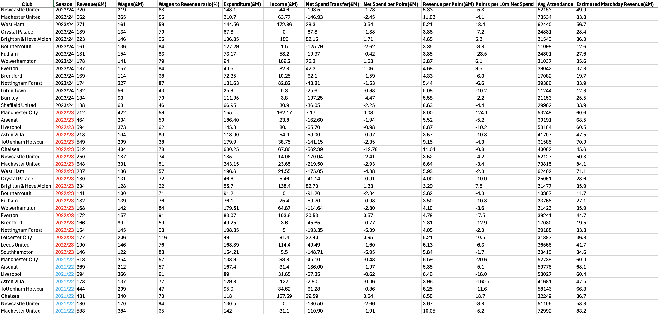
Figure 3:Final Version Dataset

Data Cleaning and Pre-Processing:
Before any analysis or visualisation could take place, the dataset underwent several data cleaning and pre-processing steps to ensure consistency, accuracy and readiness for the Tableau integration. In total, five different versions of the dataset were created through this process, each building upon the last with improvements in structure, completeness and analytical value. In this phase of the project, the data cleaning and Pre-Processing were carried out in SQL and Excel to ensure accuracy before importing the data into Tableau. SQL was used to ensure data integrity and support the larger, more structural aspects of the dataset, like duplicate entries, null or missing values or incorrect data types, while Excel was used to perform more minor, manual adjustments, such as correcting club names or spelling errors, adding or refining calculated metrics.

The initial version of the dataset consisted primarily of raw financial and performance data. However, the formatting of key metrics varied significantly; many monetary values were often unstandardised and needed to be converted into consistent units (£M, millions of pounds) to allow for comparison across clubs and seasons. Later versions of the dataset introduced derived metrics that added more analytical depth, which included:

- Revenue per Point
- Point per Point
- Win Rate

These metrics were calculated using existing financial and performance data and were key to highlighting relationships between financial investment and on-pitch results. Each version of the data set also addressed data quality issues; incomplete or inconsistent records were either corrected using reliable external sources or excluded where necessary. For example, missing financial data for some clubs in earlier seasons was carefully managed to avoid skewed results. One specific metric, Avg Attendance, was a rough estimate of each club’s attendance for that specific season. Additionally, categorical fields such as Club and Season were standardised to avoid discrepancies, ensuring consistent naming throughout the different seasons. Other fields were also checked for correct data types; for instance, numerical fields were formatted for computation and categorical values were prepared for filtering. The final version of the dataset also included a clean and analysis-ready structure for the Tableau phase of the project. By the end of this process, the data had evolved significantly in quality and usability.

KPI Design and Metrics:
A KPI is a key performance indicator that is a quantifiable measure of the performance of a specific measure or objective (Qlik, 2021). The KPIs selected for this project were carefully chosen based on their relevance to football club performance, financial health and their ability to support data-driven decision-making for stakeholders.

Defined KPIs:
KPI Name | Formula | Purpose
Wage-to-Revenue Ratio | Total wage / Total Revenue x 100 | Assesses clubs’ financial sustainability, higher values show overspending on wages
Net Spend per Point | Net Transfer Spend / League Points | Measures financial efficiency in relation to league performance
Revenue per Point | Revenue / League Point | Indicates revenue efficiency tied to actual on-field output
Points per £10M Net Spend | League points / (Net Spend / 10) | Evaluate net spend efficiency, higher value imply better use of resources
Wage Efficiency | Wage / League Points | Shows cost per point, to understand squad value
Goals Per Match | Total Goals Scored / Matches Played | Measure how effective team’s offensive
Goal Difference | Goals For – Goals Against | Performance benchmark of overall team strength
Matchday Revenue | Revenue/ Matches Played | Insight into matchday profitability
Win Rate | Wins / Total amount of games x 100 | Tracks overall success rate over the season
Goals Per Game | Goals Score / Total amount of game x 100 | Measure attacking output and overall offensive performance
Goals Conceded Per Game | Goals Conceded/ Total amount of games x 100 | Evaluate how effective team’s defensive
Table 1: KPI Metrics
These KPIs were chosen to provide a comprehensive and meaningful analysis of both financial and performance dimensions for Premier League Clubs. From a performance perspective, metrics like Goals per Game, Goals Conceded per Game, Goal Difference, and Win Rate offer clear indicators of a team’s effectiveness on the pitch. These KPI’s help identify teams’ strengths and weaknesses in their attack and defence and show how consistent they are across a season. Financially oriented KPIs, such as the Wage-to-Revenue Ratio, Revenue Per Point, and Wage Efficiency, were included to assess the sustainability and cost-effectiveness of club operations. These KPI are particularly valuable when comparing clubs with different financial models, revealing how well resources are being managed relative to their performance. For instance, a lower wage to revenue ratio suggests a club is operating within it means, while a high wage efficiency indicates more points are being gained per pound on wages. Strategic metrics like Net Spend per Point and Points per £10M net Spend were introduced to evaluate transfer market efficiency. These KPIs help assess whether clubs are translating their transfer investments into on-field success. Additionally, Market Value offers insight into the quality and commercial value of a club’s squad, and Matchday Revenue provides an estimate of income generated per game, which can be useful for evaluating stadium profitability per game. The KPIs were designed to balance performance and financial insights to ensure that the dashboard is accessible to a wide range of users, from analytics to executives.

Dashboard Design Process:
The dashboard was designed to provide an intuitive and insightful interface that seamlessly blends financial and performance data for Premier League clubs. Throughout the development process, the focus was on delivering a dashboard that is visually clean, interactive and supports both a high-level overview of performance and financial analysis.

Originally, the plan was to create three separate dashboard pages, each dedicated to a different category of club based on performance:

- A high-performing club (Arsenal)
- A mid-table club (Aston Villa)
- A lower-performing club (Southampton)

Each page would display metrics, financial breakdowns, and league performance for the respective club across multiple seasons. However, this approach changed due to efficiency and usability concerns. Instead, the dashboard structure was changed to two main pages, which simplified navigation and allowed the user experiences to remain focused and uncluttered:

- Premier League Club Dashboard: The main page of the dashboard includes filter controls that allow users to select any club and season, which will update all KPI tiles and charts. This not only replicates the original intent of showing individual club views but also makes the dashboard scalable, avoiding the need to have separate pages for each type of club. It also shows 4 different charts: the Wages vs Points, Net Spend vs Points, Cost Per Point and Wins Per Wage.

- Data View Dashboard: The data view page presents the entire dataset in a clean, scrollable format. Filters and search tools are included, allowing users to find specific values, clubs and seasons. This dashboard page acts as a reference tool for anyone wanting to inspect the dataset, verify KPIs or explore other metrics.

The primary Dashboard uses an executive style layout, where KPI tiles at the top show different metrics of the clubs, and below are 4 key charts that visualise the relationship between financial investment and performance outcomes. To make the dashboard interactive and dynamic, features like the club filter let users select any of the 20 clubs, and all visuals and KPIs automatically update, and a season filter to filter between all 3 different seasons or all 3 seasons together. Charts are equipped with information hover interactions to show additional details about the data hovered upon, like club, league position and more.

Charts Construction:
The dashboard incorporates four main charts designed to blend finance data with on-field performance metrics, offering a multi-dimensional view of club efficiency. The Wages vs Points scatter plot illustrates the relationship between wage expenditure and league points, helping users evaluate whether higher spending correlates with better results. Similarly, the Net Spend vs Points charts visualise how effective clubs convert their net spend (Expenditure – Income) into league points. Both of these scatter plots are interactive, responding dynamically to filters for club and season, enabling users to explore patterns over time or isolate individual team performance. In contrast, the Cost Per Point and Wins Per Wage bar charts do not change when a specific club is selected. This is because these two charts provide a league-wide comparison to benchmark club efficiency and performance. However, they still respond to the season filter, allowing comparisons across different time frames. The Revenue by League Position line chart plots club revenue against their finishing position in the table. When filtered by a single club, it draws a line connecting that team’s performance across multiple seasons, visually showing any financial progression or regression relative to its league success.

Results & Analysis:
This chapter presents the key findings from the completed data analysis and visualisations. The results are derived from a dataset that combines financial and performance metrics from the Premier League across three seasons from 2021 to 2024. This chapter evaluates how the selected KPis reveal insights about the club. Performance, efficiency and financial sustainability. The core aim of the dashboard was to assist stakeholders of a football club, such as club executives and analysts, in understanding how financial investment translates to on-field success. This chapter will begin by showcasing the completed dashboard, followed by analysing the KPIs through visual trends across multiple seasons, followed by the findings. Additionally, this chapter will show how the dashboard successfully adapts to different user queries through filtering and interaction. It will also highlight cases where financial spending does not always align with performance and expose inefficiencies in spending and areas where clubs have overperformed or underperformed relative to financial expectations.
Overview of the dashboard:
The final dashboard is divided into two distinct pages: the Premier League Financial and Performance Dashboard and the Dataset View. The main dashboard page offers a high-level overview through a combination of KPI tiles and performance financial charts, enabling users to immediately identify club-level trends and outliers. The second page is the dataset view that presents a searchable and filterable table of the raw data set, offering detailed access to every data point for deeper analysis.
At the top of the dashboard are six KPI tiles that display financial metrics, including Expenditure, Net Spend, Revenue, Wages and Income. These metrics automatically update based on the selected season or club, offering a fast and intuitive summary of key indicators.
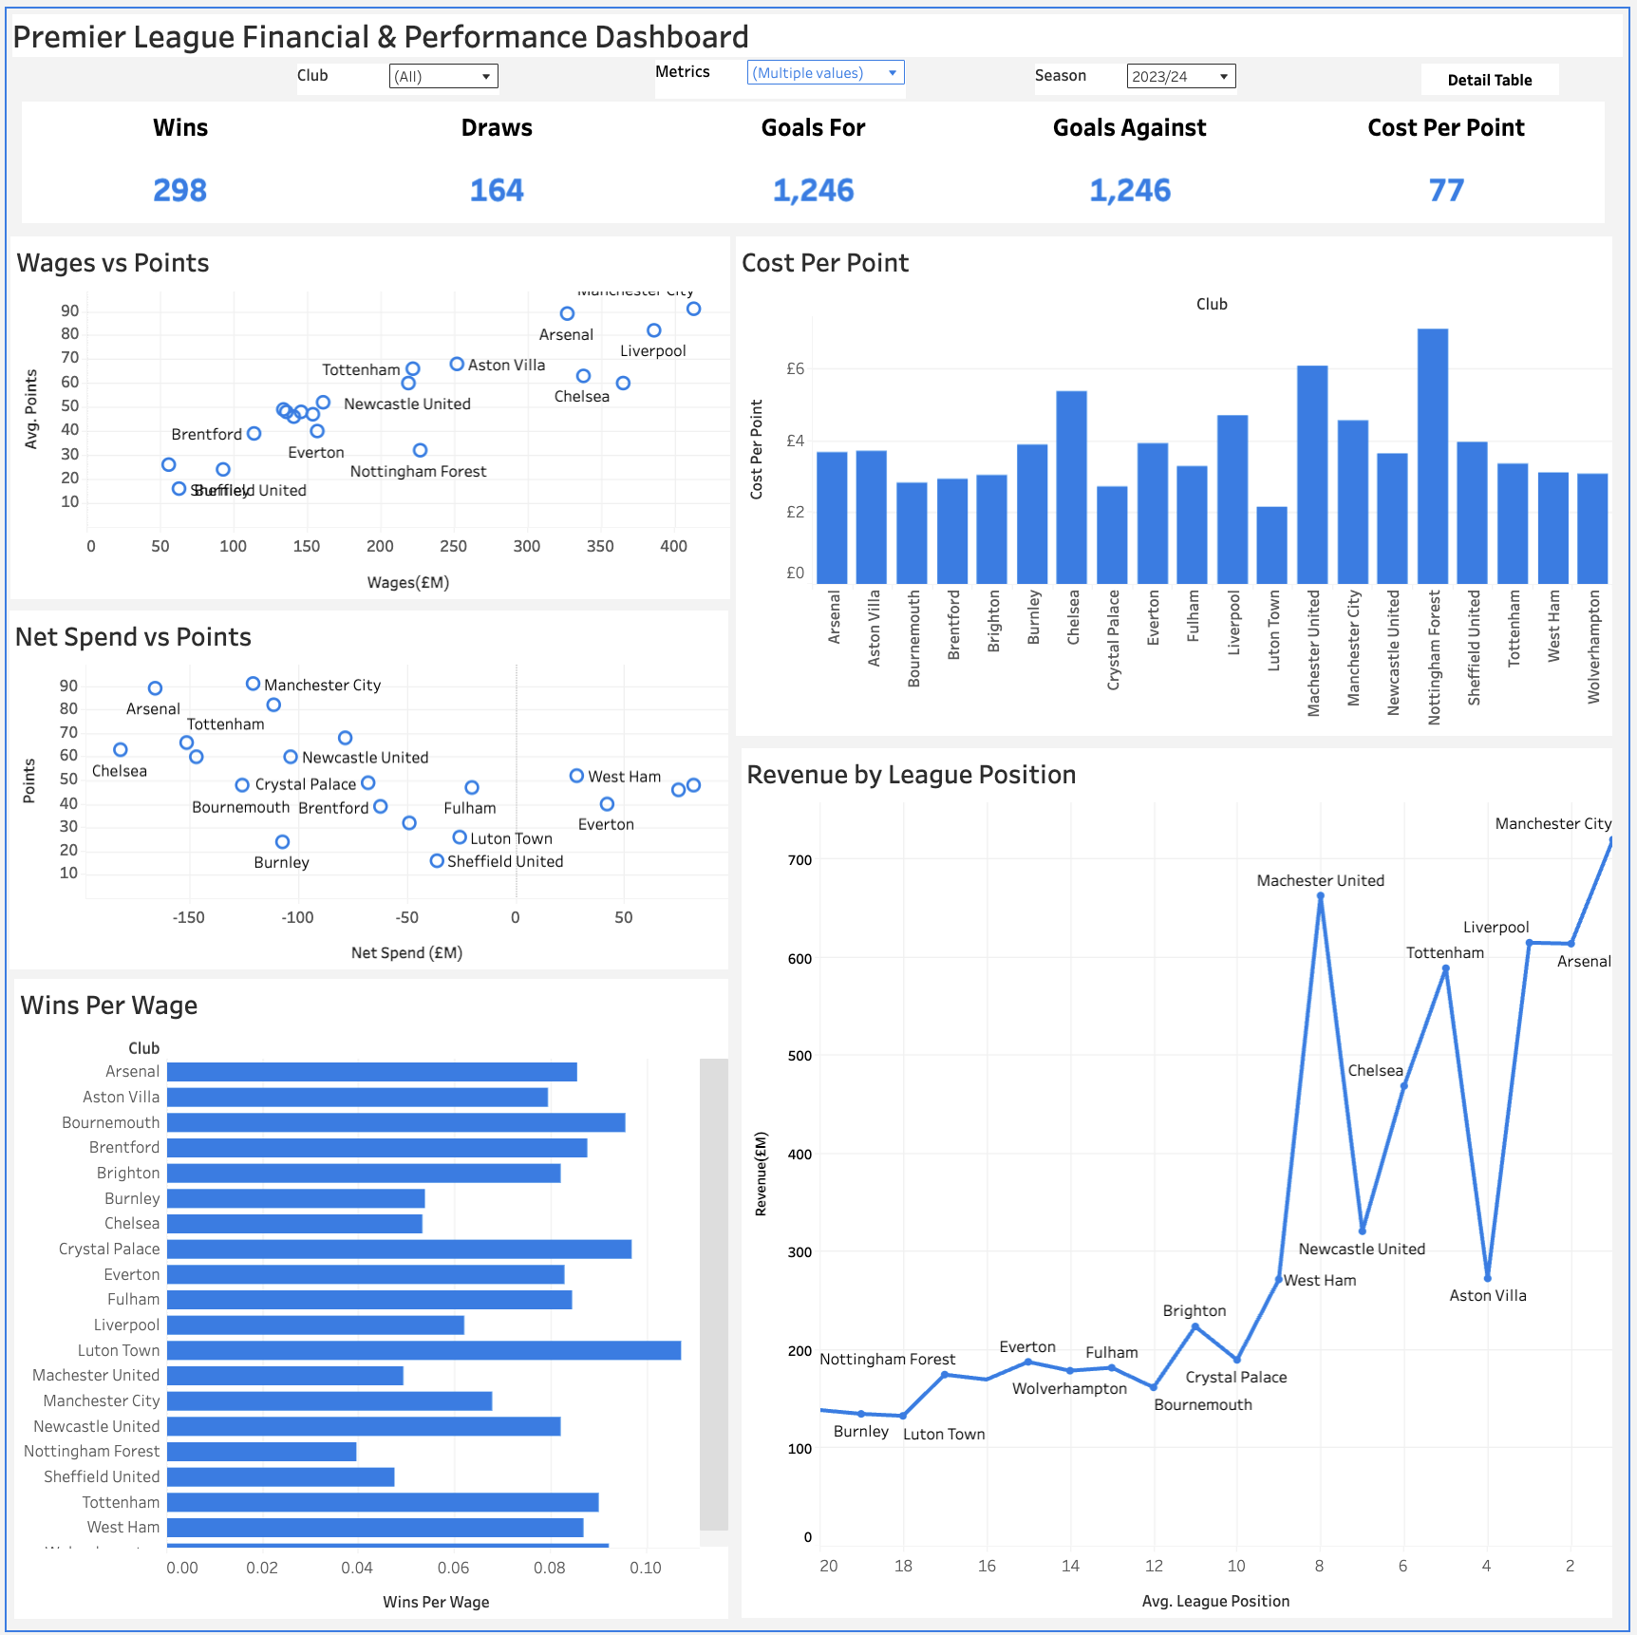
Figure 4: Premier League Financial & Performance Dashboard
Beneath the KPI section, the dashboard splits into 5 charts:

- Wage vs Points: The Wages vs Points scatter plot below shows data from three Premier League seasons, 2021/22, 2022/23 and 2023/24, displaying each club’s total wage expenditure against their average points per season. This chart enables multi-season trend analysis to evaluate the relationship between financial investment in player wages and sustained on-field performance. Clubs with a higher wage bill tend to achieve higher average points, and Manchester City consistently appears at the top-right corner of the graph, showcasing a strong return on investment by maintaining both high wages and league points across the three-year period. Liverpool and Arsenal also fall into the category of high-spend, high-performance category. However, the chart also highlights significant efficiency outliers. For instance, Brighton achieved a respectable average point with a significantly lower wage expenditure, positioning themselves as one of the most financially efficient teams over the three seasons. This kind of insight is especially useful for clubs seeking to benchmark themselves against overperforming peers. Other clubs, such as Chelsea and Manchester United, demonstrate higher wage costs but a less impressive return in league points, suggesting inefficiencies or underperformance relative to their financial investment. Chelsea, in particular, had one of the highest but failed to achieve proportionally higher points, raising questions about recruitment, squad utilisation or managerial instability over the seasons. Clubs positioned in the lower left side, such as Burnley, Luton, Sheffield United and Watford, reflect the expected pattern of lower wages resulting in lower points. These clubs typically operate with tighter budgets and often face regulation battles and actual regulation from the Premier League. Mid-tier clubs like Aston Villa, Newcastle United, Brentford and Crystal Palace display a more balanced performance to spend ratio, achieving mid-table average points on moderate wage budgets. The use of having the capabilities of using a multi-season chart provides a holistic view of how financial outlays on wages relate to performance over time, helping to identify consistently overperforming or underperforming clubs. It also allows for more stable analysis by smoothing out anomalies from single season fluctuations and offering a broader understanding of club strategy and effectiveness.
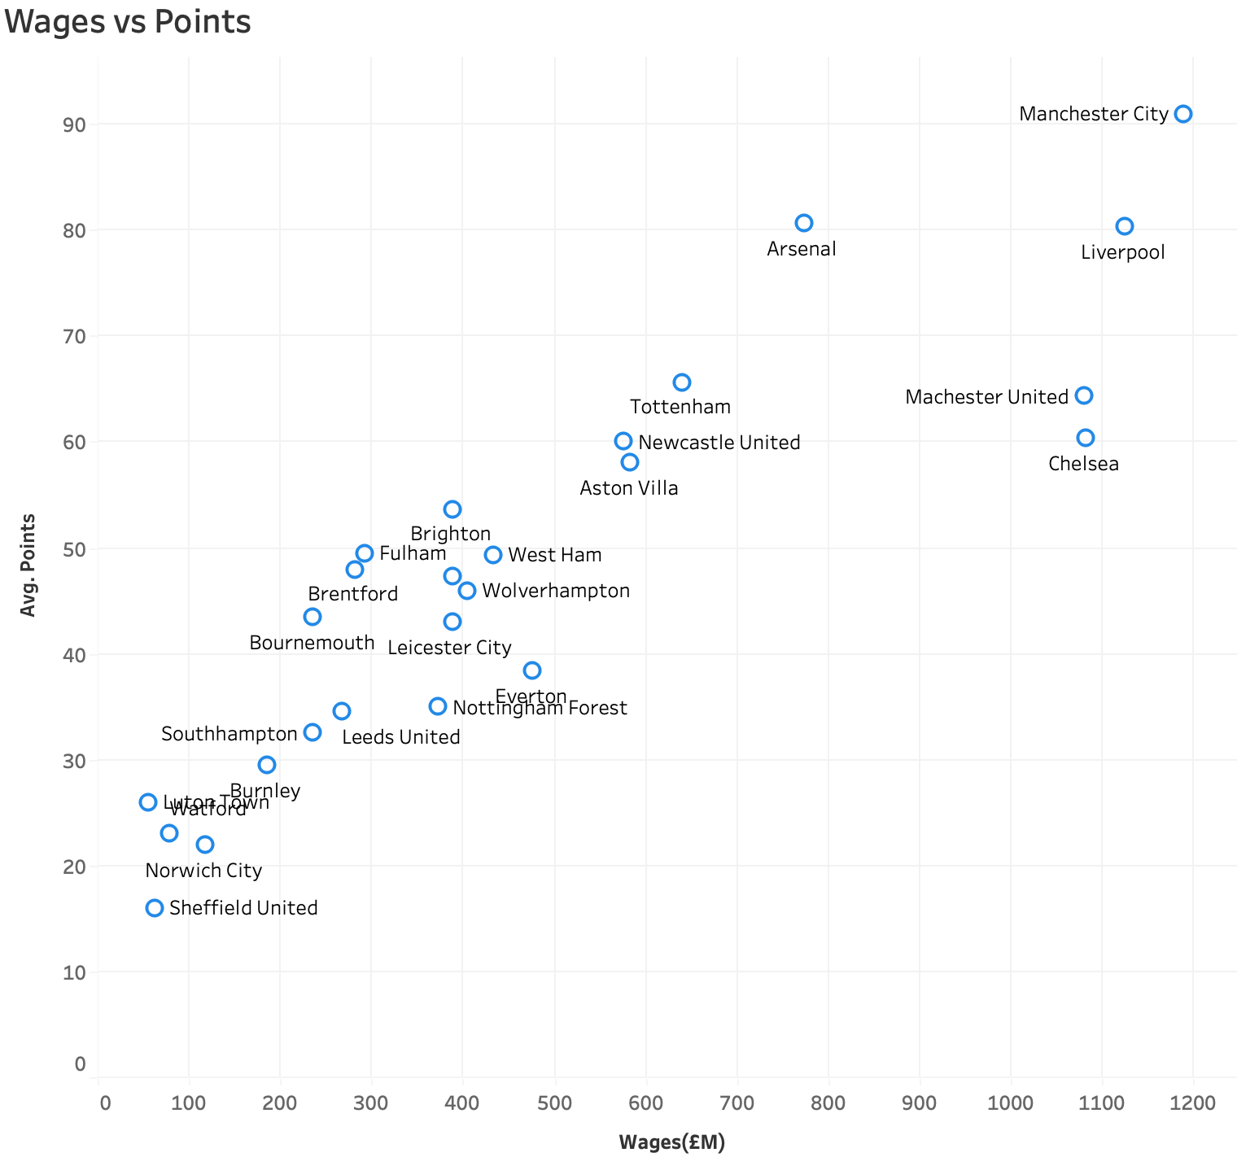
Figure 5: Wages vs points

- Net Spend vs Points: The Net Spend Vs Points chart is designed to highlight the relationship between a club’s transfer activity and its on-pitch performance during the Premier League Season. The chart specifically plots each club’s transfer spend, which is calculated as the difference between the expenditure and income from player transfers and plots the total points the club earned during the season. The x-axis represents the Net Spend(£M), while the y-axis shows Total Points accumulated during the season. For example, the chart below shows data from the 2023/24 season, where Arsenal and Man City appear in the top left, suggesting they achieve high points despite substantial negative net spend, reflecting highly efficient and successful transfer strategies. In contrast, clubs like Brighton and Wolverhampton, located in the far right of the chart with positive net spend, earned fewer points, meaning unsuccessful in terms of league points, but have shown good transfer activity. Sheffield United, which also had a relatively low net spend, is situated near the bottom with minimal points, highlighting poor performance regardless of spending level.

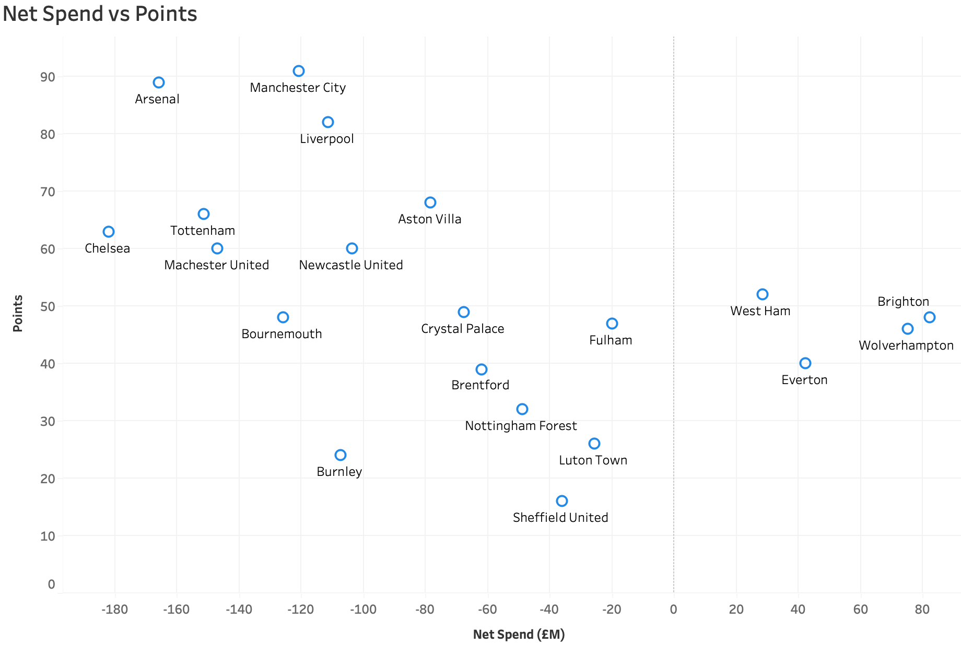
Figure 6: Net Spend vs Points

- Cost Per Point: Cost Per Point is a bar chart showing how much each club spent in millions of pounds for every point earned in the league. This KPI combines both financial and performance metrics into a single value, offering a straightforward measure of return on investment. The cost per point is calculated by dividing the total wage expenditure by the number of Premier League points they secured that season. The chart highlights stark contrasts in spending effectiveness. In the 2023/24 season, Luton Town, which is a newly promoted side, stands out as the most efficient team in the league. Despite having one of the lowest wage bills, they managed to earn points at a significantly lower cost than almost any other club. This suggests that the club has careful resource management, effective coaching and a tactical system that maximises output from a limited financial input. Other clubs like Nottingham Forrest exhibit the highest cost per point, exceeding £7 million per point. This suggests underperformance relative to their wage expenditure, which could point to inefficiency in squad building, misallocated resources, or challenges in converting investment into results on the pitch. Manchester United and Manchester City also feature on the higher end of the cost spectrum, which can be explained by their high wage bills, raising questions about efficiency when compared to lower-spending, higher-performing clubs. Chelsea, another high-spending club, also demonstrates a relatively high cost per point. While they managed to earn a fair number of points, the level of investment in terms of wages did not translate into proportional returns, indicating potential concerns around performance efficiency. Clubs like Brentford, Bournemouth, and Crystal Palace reflect a strong value for money, maintaining low to moderate wage expenditure while securing a good return in points. Other Clubs like Arsenal, Aston Villa and Liverpool fall in the middle of the cost efficiency spectrum, indicating that while their investment are considerable, they tend to deliver consistent league performance. These clubs showcase a more balanced approach between spending and performance. This chart is especially useful for financial analysts, stakeholders, or owners to looking to understand not just how much a club spends, but how well that spending translates into competitive outcomes.
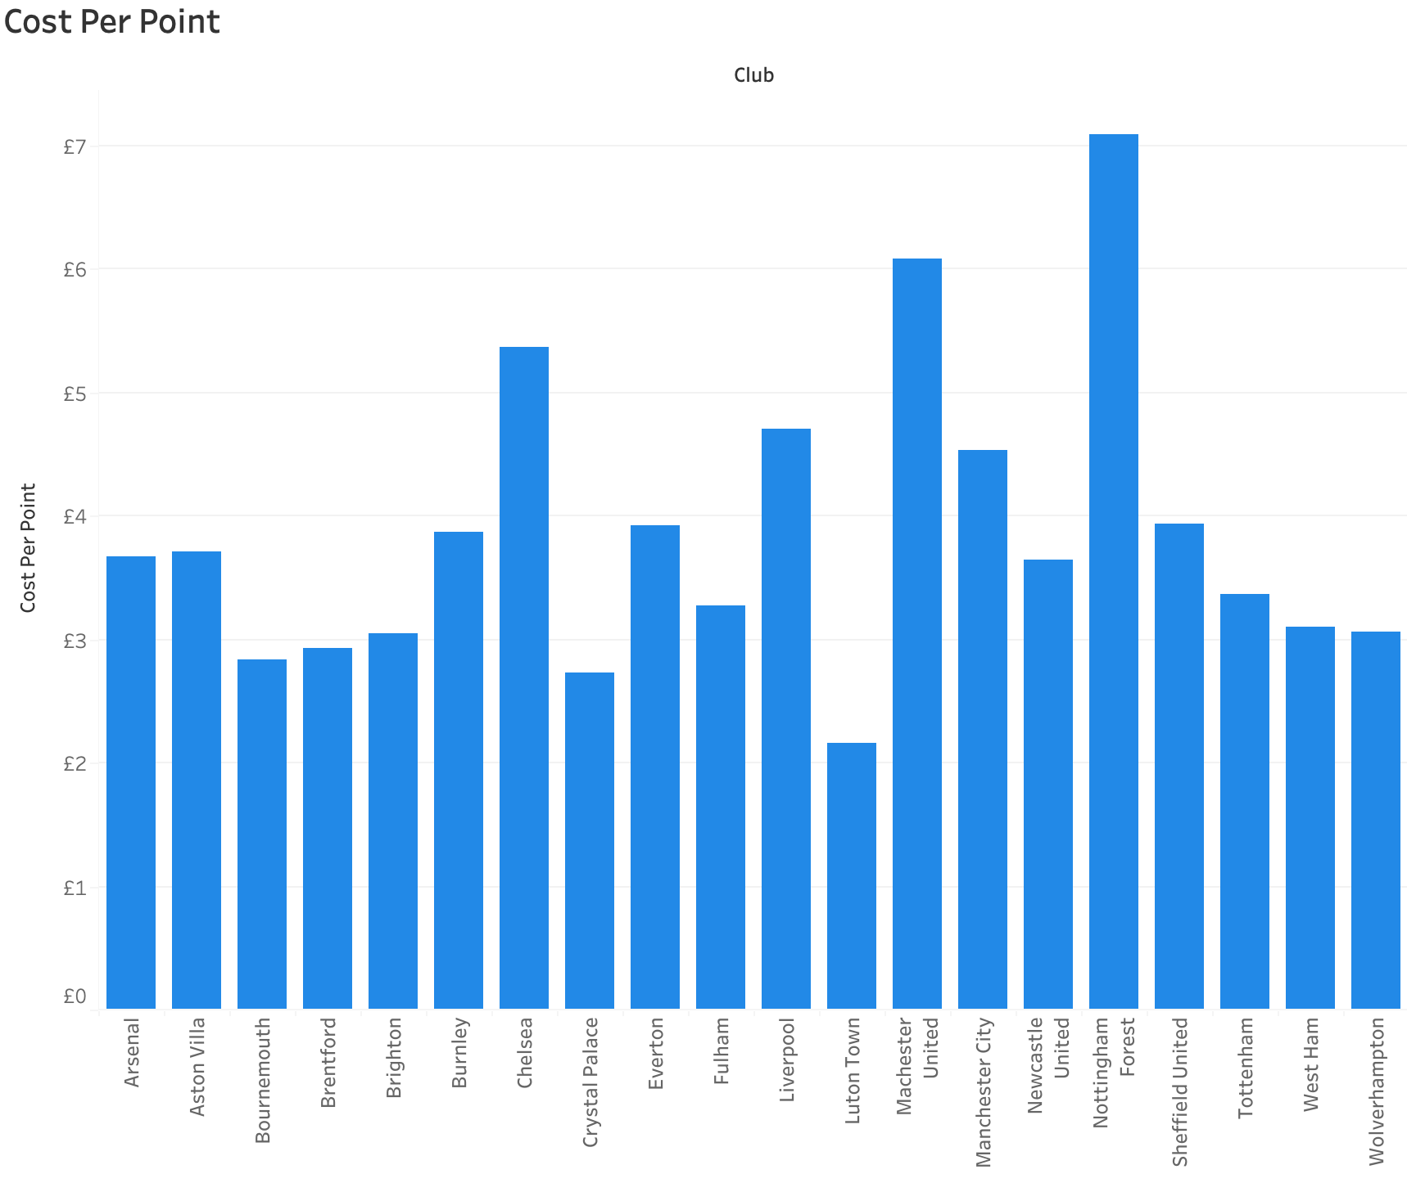

Figure 7: Cost Per Point

- Wins Per Wage: The Wins Per Wage is a bar chart that visualises how effectively Premier League clubs turned their wage expenditure into actual wins. This KPI was calculated by dividing the number of league wins a club achieved by its total annual wage bill, resulting in a performance score. The higher the ratio, the more wins a team secured per financial outlay, indicating a greater return on investment in terms of on-pitch results. While a club may finish high in the table, if their wage bill is disproportionately large, their wins per wage ratio may still be poor; conversely lower-finishing club with a modest wage bill can stand out as an efficiency leader using this chart. In this 2022/23 season, Brentford and Brighton emerge as clear frontrunners in terms of financial efficiency, despite operating with a significantly smaller wage budget compared to the traditional top six sides of the league, and both clubs managed to secure a higher number of wins, showcasing excellent performance relative to financial input. Their success reflects effective management strategies, a good recruitment strategy and a cohesive team structure that maximises limited financial resources. On the other hand, clubs like Sheffield United, Norwich City and Watford appear at the lower end of the chart, indicating that their wage investments did not translate into competitive success. These clubs recorded very few wins relative to what they spent on wages, suggesting inefficiencies in the squad construction, player performance or tactical execution on the pitch. Arsenal and Aston Villa also perform well with their high wins per wage ratios. Arsenal’s presence near the top of the chart is particularly strong given their good league performance and moderately high wage bill, suggesting not just quality performance but also cost effectiveness. Meanwhile, Manchester United, Chelsea and Liverpool, despite higher overall wins and fall into the mid to lower end of the efficiency scale due to their extremely high wage expenditures.
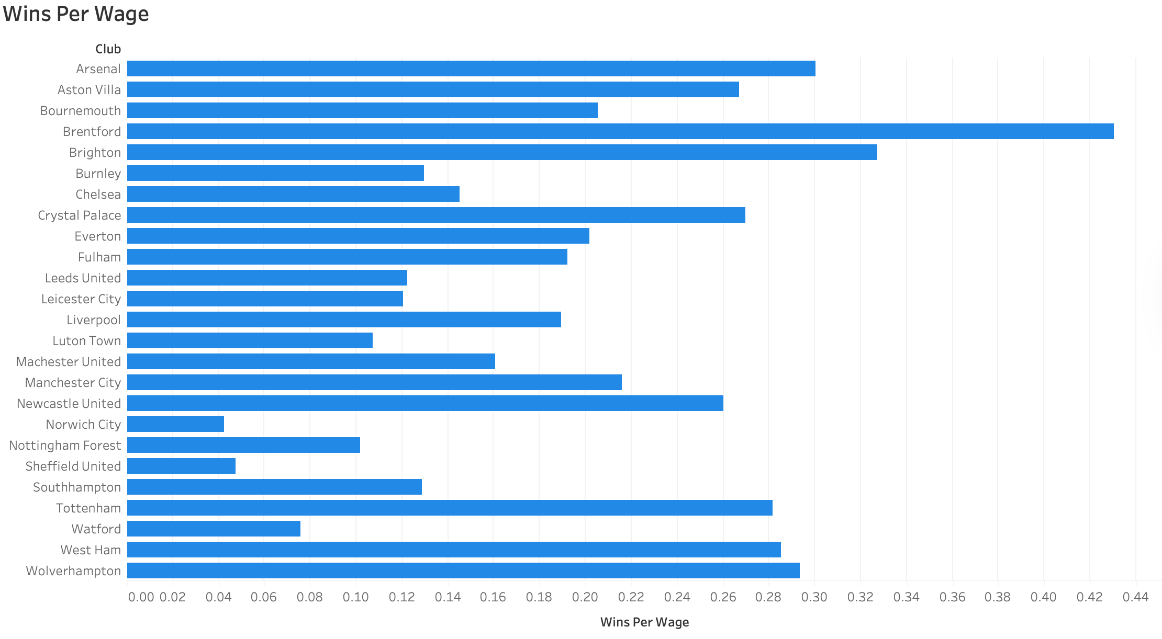

Figure 8: Wins Per Wage

- Revenue by League Position: Revenue by League Position is a line chart plotting each club’s league position against their total revenue. The x-axis is sorted in reverse order, with the 1st place on the right side, which makes it easier to see how revenue typically increases with better league position. The chart below shows data from all three seasons, and you can see a clear upward trend, as clubs finishing in the higher positions tend to report significantly higher revenues. This is expected due to increased broadcasting income, Champions League qualification and larger fan engagement. For instance, Manchester City, Liverpool and Manchester United all appear in the top right section of the graph, showing both league finishes and a high source of revenue that exceeds 1.8billion across the three seasons. An outlier between the top clubs is Arsenal, which appears below clubs like Liverpool and Manchester City, in revenue, despite finishing higher on average across the three seasons, which may reflect in the differences in matchday income, commercial strength or European competition revenue. Meanwhile, other clubs like Tottenham and Chelsea maintain a strong revenue position, possibly due to Tottenham’s larger stadium capacity and Chelsea’s commercial power. At the lower end of the graph, clubs like Norwich City, Burnley and Luton Town, all of which averaged lower league finishes between 18th and 20th, generated lower revenue totals. These clubs typically face regulation threats, receive fewer broadcasting fees and have smaller commercial operations. However, the line chart is not perfectly linear; for example, clubs like West Ham and Brighton slightly outperform their average league position in terms of revenue, which could be due to other competitions like cup runs or European qualification. Similarly, Everton, despite being in the mid to lower league positions, has relatively high revenue compared to other clubs, which may be from its long-standing Premier League presence and its strong fan base. The chart is effective for illustrating financial disparities in the Premier League and helps contextualise how on-pitch performance contributes to revenue. It visually reinforces the notion that success breeds financial rewards, but also highlights that brand power, commercial strategy and historical stature play a vital role in driving club income.
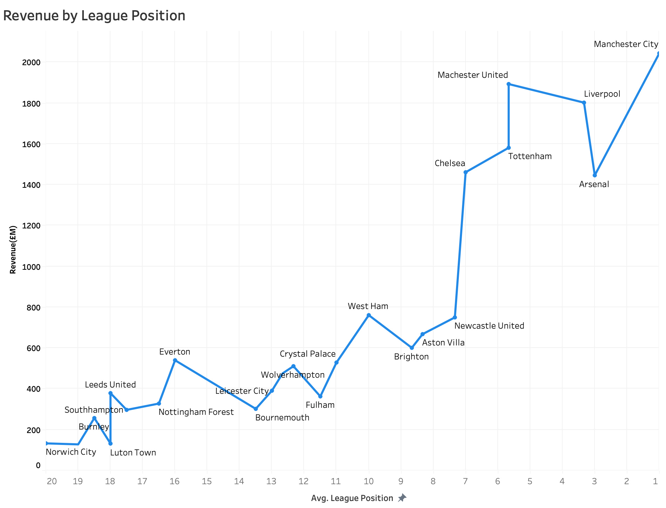
Figure 9: Revenue by League Position

Each of these charts was selected to demonstrate the interplay between financial data and on-pitch performance data, ensuring that users can identify both good practices and inefficiencies within each club. The mix of different charts, like scatter plot, line charts and bar charts, was specifically chosen to offer a mix of relationship-based and comparative visualisations.
Filtering and Interactivity:
At the top of the dashboard are two filters: club and season. These allow users to dynamically explore the dashboard by isolating specific seasons or clubs. When a particular club is selected, charts such as Revenue by League Position adapt to show the club’s data over multiple seasons. This is especially useful for tracking year-on-year performance. However, it is important to note that Wins per Wage and Cost Per Point do not change when the Club filter is applied. This is by design, as these charts are meant to represent league-wide comparisons, and updating them based on a single club would remove their comparative context. To avoid confusion, users can visually confirm this by observing that all clubs remain visible in these charts regardless of the filter selection. The use of the tooltips across all visual elements of the dashboard further enhances the interactivity, as when hovering over data points or bars, users are presented with figures such as “Wages: 110 million” or “League Points: 71”, which helps provide context without cluttering the dashboard. The fonts, gridlines and axis labels were kept minimal to preserve a clean and readable layout, in keeping with executive dashboard principles.
Dataset View Page:
The second page provides a comprehensive view of the entire dataset, including all clubs across the 3 seasons. Columns include raw data, Revenue, Wages, Expenditure, income, etc, as well as the calculated KPIs such as Net Spend, Wage-to-Revenue Ratio, Cost Per Point, Wins Per Wage and others. This table offers interactive filtering on the left-hand side, where users can select clubs and seasons, and it also includes a highlight detail and a search bar to quickly locate any specific value. This page ensures transparency and allows users to validate the visual summaries shown in the main dashboard, and it also supports more technical analyses and data exploration, especially for users who want to view metrics across multiple clubs or examine outliers more closely.
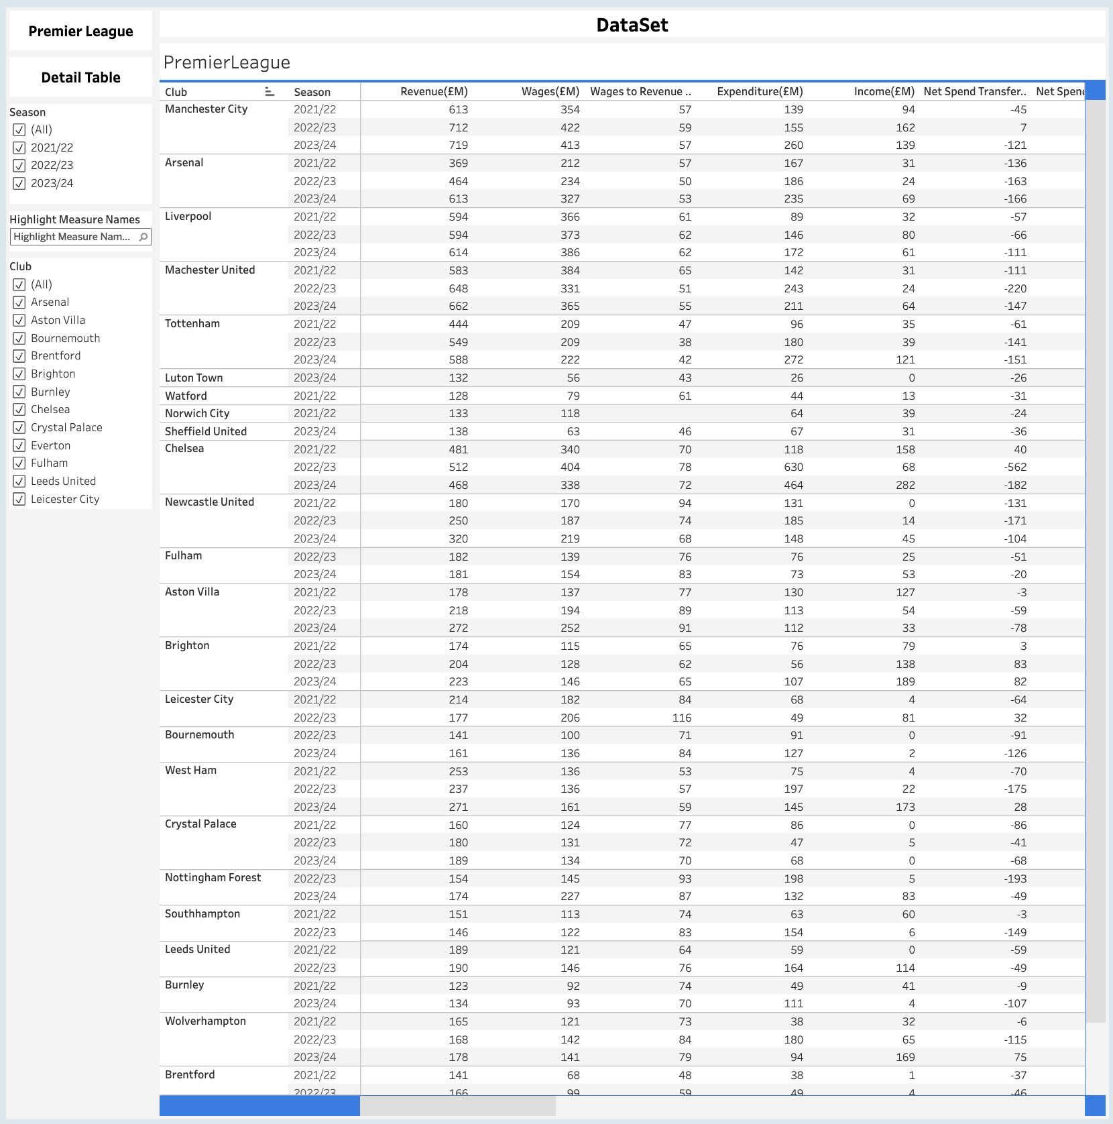
Figure 10: Detailed Table(Raw Dataset)

Evaluation:
The next chapter of this report is to evaluate the outcomes of the project in relation to its initial objectives and research question. The evaluation section is crucial to this project as it will help show how the project has met or failed the objectives and will identify any room for improvement (Khalid, Kitchen and Asuelimen, 2023). While this chapter will present and analyse the results from the Premier League and the performance Dashboard, this section will have an assessment of how effectively the project addressed its aims, the strengths and weaknesses of the project and the overall value of the project. In this evaluation, we will look at the project from two different perspectives, internally and externally. Internally, it will be evaluated from the design quality, data integrity and alignment with the project objectives. Externally, it will evaluate the practical implications of the dashboard for the stakeholders, such as analysts, club executives and coaches. Additionally, this chapter will reflect on the methodology of the project, including the choice of dataset, the use of Tableau for the visualisation and the approaches taken to designing the key performance indicators and interactive dashboards. In order to maintain the original direction of the study, the evaluation will be structured around four primary objectives:

- To collect, process and validate financial and performance data from Premier League Clubs, ensuring the dataset was reliable and fit for visual analysis.

- To design and implement key performance indicators (KPI) that effectively represent both financial and performance metrics.

- To develop a Tableau dashboard that integrates financial and performance measures into an interactive and user-friendly platform.

- To critically analyse the relationship between financial and performance data in order to provide insights into Premier League club efficiency.

By using these objectives, the evaluation will determine the extent to which objective was achieved, as well as highlight any gaps, challenges or limitations within the project.

Evaluation of Data Collection and Preparation:
The first object was to collect, process and validate financial and performance data from Premier League Clubs during the 2021/22 season to the 2023/24 season in order to establish a reliable dataset suitable for dashboard visualisation. Data were primarily obtained from publicly available sources, such as Transfermarkt, clubs’ financial statements, and the official Premier League Website. Some clubs published detailed breakdowns of wages, revenue and net transfers spent, whereas other clubs, like lower-tier clubs, presented aggregated figures, which introduced challenges in standardising the dataset. Despite these inconsistencies, efforts were made to cross-check these figures across multiple sources to improve the reliability and accuracy. The raw data underwent a structured cleaning process to ensure it was consistent and ready for analysis. Key steps during this process included:

- Standardisation of units and currencies: All financial values were converted to a single unit in millions of pounds to enable comparability.

- Handling of missing values: In cases where financial or performance data was unavailable from the official Clubs website, external sources were used to get these figures

- Metric Calculation: Metrics such as cost per point, wins per wage, and net spend were calculated by combining financial and performance variables.

While the cleaning process was largely successful, it required using estimations specifically for the smaller clubs; while these were necessary, this did introduce a degree of uncertainty that must be acknowledged in interpreting the results. The dataset covered multiple seasons of the Premier League performance and financial metrics, which provided a rich basis for longitudinal analysis. However, its scope was limited to clubs competing in the Premier League and did not extend to lower divisions or international leagues. This was an intentional design choice, but it inevitably constrained the generalisability of the findings. Another limitation relates to the static nature of the dataset. Given that financial data is typically published on an annual basis, real-time insights could not be captured, meaning that while the dashboard allows for retrospective analysis of financial efficiency and as seasons go on, the dataset becomes less reliable. Overall, the dataset can be considered suitable for the purposes of this project. Its strengths lie in its comprehensiveness across clubs and seasons, as well as the careful standardisation and validation processes that were undertaken. However, limitation in terms of data completeness, especially in the lower-tier clubs. The evaluation of these objectives highlights that while the dataset successfully provided a foundation for dashboard development and analysis, it is important to interpret results with an awareness of the inherent uncertainties in football finance data. Future research could solve these issues by integrating external datasets, such as player salaries, or using techniques like machine learning to address missing data that cannot be officially found.

Evaluation of KPI Design and Implementation:
The second objective of this project was to design and implement a set of key performance indicators that effectively represent both financial and performance dimensions of Premier League Clubs. These KPI was an important part of the project, as they provided the metrics through which meaningful comparisons between clubs could be drawn and financial efficiency could be evaluated.

The KPIs were chosen with the dual intention of reflecting financial investment and on-pitch performance. Among the most important indicators were:

- Wages vs Points: assessing the relationship between salary expenditure and league performance.

- Net Spend vs Points: highlighting how transfer activity translates into results

- Cost per Point: Measuring efficiency in financial metrics

- Wins per Wage: Evaluating success relative to player salary expenditure

- Revenue by League Position: Linking Financial income to completive outcomes

The relevance of these KPIs was a key strength of the project, as they strike a balance between being intuitive and analytically valuable. One of the primary aims of the project was to explore the relationship between financial resources and sporting outcomes. The selected KPIs served this purpose directly, as each metric provided a different perspective on efficiency. For instance, while wages vs points showed general correlations, cost per point provides a more standardised efficiency measure. This multi-approach ensured that clubs could be evaluated from different viewpoints.

The integration of KPIs into Tableau was successful in terms of both calculation and visual representation. In the visualisation process, derived fields were created within the dataset, and these were linked to filters and visualisations that allowed users to explore relationships dynamically. For example, filters enabled comparisons across clubs and seasons, giving the KPIs to be viewed differently. The visual of the KPI tiles was another positive feature; these tiles provide a glance summary of key statistics, serving as an entry point into deeper visualisations. Despite the effectiveness of the KPI framework, the KPI does have some limitations. Firstly, the KPI were constrained by the availability of the dataset; for instance, player-level data was not included, which can restrict the precision of the measures in cases where a single high value transfer or outlier wage could disproportionately affect a club’s efficiency. Secondly, KPIs could inherently not provide the correct context on why clubs could be performing badly, for example, cost per point does not consider external factors such as injuries, managerial changes or strategic differences between clubs. Similarly, revenue by league positions does not consider factors like commercial deals or European competition qualification. Finally, while the KPIs offered valuable insights into financial efficiency, they were less able to capture sustainability over time. For example, short-term overspending might show favourable ratios if a club performs well in a single season, even though the long-term financial impact could be negative. Overall, the KPIs can be considered a strong point of the project; the indicators were well aligned with the project’s objectives. They not only supported the evaluation of club efficiency but also enhanced the usability of the dashboard by giving stakeholders simple but powerful measures to view.

Dashboard Design and Functionality:
The third objective of this project was to develop a Tableau dashboard that integrates financial and performance measures into an interactive and user-friendly platform. The dashboard is the centre piece of the project; therefore, its evaluation must consider usability, design principles, interactivity and overall effectiveness.

The dashboard was intentionally designed with a clear executive summary style, emphasising accessibility for users who may not have deep technical expertise in data analysis. The inclusion of the KPI tiles at the top of the main page provided instant insight into high-level financial and performance metrics, allowing users to quickly get insight into the Premier League and clubs before deeper analysis. The layout followed a structured design, just below the KPI tiles are more detailed visualisations such as Wage vs Points, Net Spend vs Points and Revenue by League Position. This structure improved navigation of the dashboard and reduced cognitive load, ensuring that users could explore the dashboard without confusion. One of the dashboard’s most valuable features was its interactive filtering system, which allowed users to choose specific clubs and seasons. This functionality transformed the dashboard from a static report into a dynamic analytical tool, where users could explore questions such as “How efficient was Arsenal compared to Arsenal in 2021/22 compared to Chelsea?” or How has Aston Villa's cost per point evolved over time?” The use of two pages in the dashboard provided a balance between data visualisation and data transparency. This design ensured the dashboard’s credibility, as users were not limited to pre-designed charts but had access to the actual dataset.

The dashboard followed several key principles of effective visualisations:

- The dashboard provides clarity in its minimalist design choices that ensure charts are free of unnecessary information, keeping attention focused on the data itself.

- The dashboard provided consistently in its fonts, colours and chart types was standardised across the dashboard.

- The dashboard provides comparability in having similar axes and scales where possible, making cross-chart comparisons intuitive

With the many strengths the dashboard has it does have some limitations. First it the visualisations were based on the dataset, which had limitations. In cases where financial data had to be gathered from external sources, it may not fully capture the full story of a club. Secondly, while Tableau offers powerful visualisations and interactivity features, certain advanced customisations could not be fully embedded, whereas other visualisation tools could have been considered, such as Power BI. The dashboard was primarily for exploratory analysis rather than predictive modelling. While it enables users to examine historical relationships between finances and performances, it does not incorporate forecasting, such as projecting future costs per point or simulating the effect of different wage strategies. Overall, the dashboard can be considered a successful outcome of the project. It achieved its goal of providing an interactive, user-friendly and visually clear representation of the relationship between financial and performance metrics in the Premier League.
Results and Insights:
The fourth objective of this study was to analyse the relationships between financial and performance outcomes in order to provide insights into the Premier League clubs’ efficiency. The evaluation of this project considers not only the findings from the results but also the extent to which the dashboard and KPIs supported the results.

The results generated from the dashboard provided clear evidence of the link between financial resources and sporting outcomes. Visualisation such as Wages vs Points and Net Spend vs Points demonstrated that high expenditure often correlates with stronger league performance, particularly for clubs consistently finishing near top of the table. At the same time, metrics like Cost per Point and Wins per Wage highlighted notable exceptions, showing that some clubs achieved competitive outcomes without having a high spend. Several meaningful insights were produced from the project, such as clubs with the highest wage bills and transfer spending, such as Manchester City, demonstrated strong positive correlations with league success, reinforcing the argument that financial power provides a competitive strength. Certain mid-table clubs, such as Brentford or Brighton, in specific seasons, showed high efficiency ratios in Cost per Point, suggesting that effective recruitment and coaching strategies can compensate for smaller budgets. Some traditionally large clubs at times displayed poor cost efficiency, spending heavily without a proportional return in league performance, which underscores the risk of mismanagement despite financial strength. The Revenue by League Position visualisation confirmed the strong link between competitive performance and financial inflows, particularly through broadcasting and prize money. These insights illustrated that the dashboard was not only descriptive but also interpretive, enabling stakeholders to identify patterns of efficiency and inefficiency across clubs and seasons.

While the results were effective in generating insights, some improvements could have been made. The dashboard visualisations demonstrate associations between spending and outcomes, but they did not prove causation or account for other factors like injuries, fixture congestion or tactical differences. The reliance on aggregate financial data meant that nuanced dynamics at the player level or positional level could be fully captured. For example, a single marquee signing may distort net spend figures without reflecting the overall efficiency of squad building. The results were confined to the Premier League, although this provided depth within one of the world’s most financially dominant leagues, it limited opportunities for cross-league comparisons or broader generalisation about football economics and performance. The dashboard primarily focused on financial and performance metrics, leaving out other potential determinants of success such as youth development, managerial stability, or club infrastructure. As a result, while the findings were insightful, they only represent half the picture of football performance.

Despite these limitations, the results and insights generated by the dashboard were valuable. From an academic view, they provide evidence supporting the relationship between finance and performance, while also highlighting the importance of efficiency. It also offered stakeholders a tool for benchmarking clubs against peers and identifying over- or underperforming clubs. Overall, this objective was successfully achieved as the project demonstrated that financial data, when combined with performance measures and visualised effectively, can produce valuable insights.
Overall Evaluation:
The evaluation of this project demonstrated that the research objectives were largely achieved, resulting in the successful development of a financial and performance dashboard for the Premier League. Each stage of the project helped to produce not only visualised data effectively but also generated meaningful insights into the efficiency of football clubs.
Achievement of Objectives:

- Data Collection and Preparation: A reliable dataset was constructed through careful cleaning, standardisation, and validation. Although limitations existed in terms of incomplete disclosures and assumptions, the dataset was sufficiently robust to support dashboard developments.

- KPI Design and Implementation: Relevant and analytically useful KPI were designed, which enabled the measurement of efficiency across financial performance. These metrics provided a strong foundation for both descriptive and comparative analysis.

- Dashboard Design and Functionality: The dashboard met its goal of being interactive, user-friendly and visually coherent. The use of the Main Dashboard and Data view Dashboard balanced accessibility and transparency, while filters and visualisation enhanced exploration in the dashboard.

- Results and Insights: The dashboard successfully revealed meaningful patterns, confirming the link between financial investment and performance, while also identifying efficient overperformers and inefficient underperformers.

The key strengths of the project lie in its integration of finance and performance data, its innovative KPI framework and the interactive dashboard. By combining these elements, the project produced a tool that is not only useful for retrospective analysis but also capable of supporting debate around football efficiency in football. Another Strength was the emphasis on clarity and accessibility, ensuring that the dashboard could be understood by a wide audience, from analysts to casual viewers. However, the evaluation did highlight limitations within the project, such as its lack of predictive nature, player level data and being restricted to just one league; while these limitations do not undermine the value of the project, they do indicate areas where future work could improve.

Throughout this project, several lessons were learnt during the research, such as data transparency being challenging in football finance. Working with inconsistent or incomplete figures highlighted the importance of the source of collected data and its uncertainty in analysis. The simplicity in KPI design enhances usability. Straightforward measures such as Cost per Point were effective not because of complexity but because of their interpretability and impact. Another lesson is that interactivity adds significant value. The ability to filter by club and season transformed the dashboard into a tool for exploration, showing the importance of user-centred design in data visualisation. Focusing solely on the Premier League allowed for detailed analysis but also meant that findings could not be generalised to other competitions. Overall, the project can be considered a successful demonstration of how financial and performance data can be integrated into a coherent analytical tool. It contributed to both academic understanding and practical applications in sports analytics.
Conclusion:
The final chapter of this report begins by looking back on the project by reflecting on how the original objectives were achieved, summarises the key outcomes of the project and the overall contribution of the project in sports analytics. Also, the chapter will outline recommendations for future research and will suggest how the project could be adapted or improved upon.

Summary of Objectives:
The main aim of this project was to investigate the relationship between financial data and performance data in the Premier League through the development of an interactive dashboard. This was achieved through different objectives, each of which contributed to achieving the overall goal. The project was able to achieve in creating a dataset that combined financial information such as wages, revenues, and transfer spending with performance indicators including points, wins and league position. The process of data cleaning and standardisation ensured consistency across clubs and seasons, although challenges remained in gathering the data. The dataset proved sufficiently reliable and comprehensive to support meaningful analysis and visualisation. The project successfully developed a set of KPI that included Cost per Point, Wages vs Points. Wins per Wage and more. These indicators were chosen for their ability to measure clubs’ efficiency, while remaining interpretable to stakeholders. The implementation within Tableau allowed for real-time calculation and visual exploration, thereby providing both clarity and analytical depth. The objective of creating a dashboard that integrates financial and performance data was achieved through Tableau. The dashboard provided an overview of financial and performance relationships through KPI tiles and visualisations. The dashboard design followed principles such as clarity, consistency and comparability, ensuring that users could easily navigate and interact with the tool. The analysis confirmed that financial resources are strongly correlated with Premier League success, with clubs investing heavily in wages and transfers often finishing at the top of the table; however, results also revealed variation in efficiency. Some clubs achieved strong returns through expenditure, while others spent disproportionately without achieving equivalent results. These findings emphasised that while financial strength is a major driver of success, managerial decisions, recruitment strategies and broader organisational factors also play a major role.

Project Contribution:
From an academic perspective, the study reinforced and extended existing research on the relationship between financial resources and sporting outcomes. While prior research has highlighted the importance of financial investment in determining success, the project applied a framework for visualising these relationships in a clear and comparative way. The introduction of KPIs contributed additional analytics that go beyond the traditional measures. By focusing on efficiency rather than financial strength, the study added a nuance to the academic discussion surrounding competitive balance and resource allocation in football. Practically, the dashboard offers tools that can be of value to a range of stakeholders. For club executives, it demonstrates how financial, and performance metrics can be monitored and benchmarked against competitors. For analysts, it provides a visual platform to support theories around club efficiency and financial management. For a wider football community, it can offer a way to explore the financial dynamics of the league without requiring advanced knowledge.
Limitations of the Project:
While the project achieved its objectives, there are limitations of the project that must be acknowledged. The most significant limitation was the variability of financial data across clubs and seasons. Clubs reported financial information with differing levels of detail, and in some cases, values such as wages and expenditure required the use of secondary sources. The data set was constructed at the club season level, which limited the ability to account for other factors in a club, such as players or match dynamics. For example, player wages or performance metrics such as expected goals would have allowed for more detailed exploration of efficiency. The focus on the Premier League ensured depth within a single competition, but it restricted the generalizability of the findings. While the Premier League is one of the most financially dominant and global leagues, having other leagues will further validate the project with different financial structures and levels of competitive balance.
Future Development:
Although this project successfully met its aims and objectives, there are several opportunities for future development. One clear opportunity is to include other domestic and international leagues, and not just the Premier League. Analysing other leagues such as La Liga(Spain), Serie A(Italy), Ligue 1(France), or even lower-tier divisions would enable comparative studies of financial efficiency across different governance structures and financial landscapes. The current project focused on a limited number of seasons. Expanding the dataset to cover at least five consecutive seasons would provide a more robust longitudinal perspective. Additionally, adding prediction seasons will allow research to explore trends in efficiency over time and could capture the impact of changing managerial or financial strategies. Future research could explore other commercial income, such as kit sales, sponsorship deals and others. Including these other metrics would paint a fuller picture of how financial strength is built and maintained and how it correlates with success. For instance, a financial metric that could be added is how much clubs generate from specific competitions, such as the UEFA Champions League, where each club that qualifies for the competition earns 15.7 million or more, depending on how far they go in the competition, domestic cup runs and other tournaments. (Dorsett, 2025). From a performance point of view, a popular metric that could be added is xG, which stands for expected goals, which is the measurement of the likelihood of goals being scored. (www.goal.com, n.d.)
Final Conclusion:
The project successfully achieved its aim of investigating the relationship between financial investment and performance in the Premier League through the development of an interactive Tableau dashboard. By collecting and validating data, designing meaningful KPIs and creating a user-friendly tool, the project was able to demonstrate both the significance of financial resources in shaping outcomes and the importance of efficiency in distinguishing clubs that overperform relative to their available resources. While some challenges, such as limited data and financial reporting, the project highlighted the value of visual analytics in sports research by bridging the analysis with practical application. Ultimately, it showed that combining financial and performance data within an accessible, interactive framework can provide insights that are both rigorous and engaging, that offer a strong foundation for future research and practical decision-making in football analytics.
References:
Gaul, G. (2024). The Best Leagues in the World (Top 10 Ranked). [online] Flick. Available at: https://footballflick.com/blogs/news/the-best-leagues-in-the-world-top-10-ranked.
Anon, (2021). Data Analyst Sports: 4 Critical Responsibilities. [online] Available at: https://hevodata.com/learn/data-analyst-sports/.
Dickson, E. (2020). Building an interactive visualization tool for athletes’ performance data. [online] DIVA. Available at: https://www.diva-portal.org/smash/record.jsf?pid=diva2%3A1467010&dswid=-1874
Fan, M., Chen, X., Liu, B., Zhou, F., Gong, B. and Tao, R. (2023). An analysis of financial risk assessment of globally listed football clubs. Heliyon, [online] 9(12), p.e22886. doi:https://doi.org/10.1016/j.heliyon.2023.e22886.

ResearchGate. (n.d.). (PDF) Performance analysis in football: A critical review and implications for future research. [online] Available at:
https://www.researchgate.net/publication/233947861_Performance_analysis_in_football_A_critical_review_and_implications_for_future_research.
Kazmi, A.H., O’Grady, M.J. and Gregory (2011). Visualization in Sporting Contexts - The Team Scenario. BIOSIGNALS 2011 - Proceedings of the International Conference on Bio-inspired Systems and Signal Processing, Rome, Italy, 26-29 January, 2011, [online] pp.536–539. Available at: https://www.researchgate.net/publication/221334208_Visualization_in_Sporting_Contexts_-_The_Team_Scenario.
Butt, A. (2024). The Rise of Data Analytics in Sports: How Big Data is Changing the Game. [online] Medium. Available at: https://medium.com/@buttabid728/the-rise-of-data-analytics-in-sports-how-big-data-is-changing-the-game-1116566fc30c.
‌Muller, J. (2023). Introducing The Athletic’s match dashboard: Our detailed snapshot of how a game unfolds. The New York Times. [online] 17 Dec. Available at: https://www.nytimes.com/athletic/5143083/2023/12/17/the-athletic-match-dashboard/.

Plumley, D., Ramchandani, G. and Wilson, R. (2018). Mind the gap: an analysis of competitive balance in the English Football League system. International Journal of Sport Management and Marketing, [online] 18(5), p.357. doi:https://doi.org/10.1504/ijsmm.2018.094344.
Transfermarkt (2025). Football Transfers, Rumours, Market Values, News and Statistics. [online] Transfermarkt.co.uk. Available at: https://www.transfermarkt.co.uk/.
Datadrive (2023). When to use Tableau vs. Excel | Compare Strengths and Use Cases. [online] godatadrive.com. Available at: https://godatadrive.com/blog/tableau-vs-excel.
PREDNY SLM. (2023). What is the difference between Microsoft Excel, SQL and Access? [online] Available at: https://prednyslm.eu/en/what-is-the-difference-between-microsoft-excel-sql-and-access.
Khan, J. (2023). The importance of Microsoft Excel in data analytics. [online] www.linkedin.com. Available at: https://www.linkedin.com/pulse/importance-microsoft-excel-data-analytics-jehanzeb-khan/.
Khalid, S., Kitchen, S. and Asuelimen, E. (2023). Evaluation in project management: what you need to consider. [online] www.apm.org.uk. Available at: https://www.apm.org.uk/blog/evaluation-in-project-management-what-you-need-to-consider/.
Dorsett, R. (2025). Champions League prize money: How much Premier League clubs could earn from revamped competition. [online] Sky Sports. Available at: https://www.skysports.com/football/news/11095/13364260/champions-league-prize-money-how-much-premier-league-clubs-could-earn-from-revamped-competition.
www.goal.com. (n.d.). What is xG in football & how is the statistic calculated? | Goal.com. [online] Available at: https://www.goal.com/en-gb/news/what-is-xg-football-how-statistic-calculated/h42z0iiv8mdg1ub10iisg1dju.
Qlik (2021). What is a Key Performance Indicator (KPI)? Guide & Examples. [online] Qlik. Available at: https://www.qlik.com/us/kpi.
Simkus, J. (2023). Longitudinal Study Design. [online] Simply Psychology. Available at: https://www.simplypsychology.org/longitudinal-study.html.
‌

‌

‌

‌

‌

‌

‌

‌

‌

